**PROJECT REPORT**

**ON**

**“INTELLIGENT TRAFFIC MONITORING SYSTEM”**

**Submitted in partial fulfillment of requirement for the award of the degree of**

**Bachelor of Technology**

**In**

**Computer Science and Engg.**



**SESSION 2019-2020**

**UNDER THE GUIDANCE OF**

**DR. R.N. VERMA**

Assistant Professor

Computer Science and Engg. Department

**Submitted by**

**Sunil Kumar Maurya (1604310052)**

**Badal Tyagi (1704310903)**

**Bhanu Prakash Singh (1604310017)**

**Aman Chaudhary (1604310005)**

**BUNDELKHAND INSTITUTE OF ENGINEERING AND TECHNOLOGY, JHANSI-284128**

**CERTIFICATE**



This is to certify that the project titled **"INTELLIGENT TRAFFIC MONITORING SYSTEM"**

submitted by the group that has successfully completed the project under my

guidance in the fulfillment of the requirement for awarding of the degree of **Bachelor**

**of Technology** in **Computer Science and Engg.** from **Bundelkhand Institute of**

**Engineering and Technology, Jhansi** during the academic year 2019-2020. This report

contains results of original work carried out by candidates under my supervision and

guidance.

**Project Group:**

Sunil Kumar Maurya (1604310052)

Badal Tyagi (1704310903)

Bhanu Prakash Singh (1604310017)

Aman Chaudhary(1604310005)

**ACKNOWLEDGEMENT**

The bliss and euphoria that accompany the successful completion of any task would be incomplete without the expression of gratitude to the people who made it possible with their every bit of help. Success in any work is credited to the hard work, but without a proper guidance it may be out of one's reach. So with reverence and honor, we acknowledge all those who helped carry out this project successfully.

We feel immense pleasure in expressing our deep sense of gratitude and heartiest respect to **Dr. RN Verma**, Bundelkhand Institute of Engineering. Jhansi for his preserving guidance and inspiration throughout the preparation of this project. We are thankful to our faculty members**Prof. A.K Solanki,** **Dr. Sanjay Gupta, Dr. Yashpal singh, Asst Prof.Shashank Gupta, Asst prof., Er. Shailendra singh, Er.Shivam Pandey,** for providing all possible facilities required for the project and for their guidance and help.

We gratefully acknowledge the blessing, useful guidance and help that we have received.

**Project Group:**

Sunil Kumar Maurya (1604310052)

Badal Tyagi (1704310903)

Bhanu Prakash Singh (1604310017)

Aman Chaudhary(1604310005)

**Project Team Detail**

Name : Sunil Kumar Maurya Name: Bhanu Prakash Singh

Roll Number: 1604310052 Roll Number: 1604310017

Name: Badal Tyagi Name: Aman Chaudhary

Roll Number: 1704310903 Roll Number: 1604310005

**TABLE OF CONTENTS**

1. Abstract ------------------------------------------------------------------------------------------------------- 7

2. Project Scenario ------------------------------------------------------------------------------------------- 9

3 Introduction -------------------------------------------------------------------------------------------------- 12

3.1 About the project ------------------------------------------------------------------------------13

3.1.1 Brief Description-------------------------------------------------------------------13

3.12 Purpose ---------------------------------------------------------------------------------------------------15

3.1.3 Objectives-----------------------------------------------------------------------------------------------16

3.1.4 Applications--------------------------------------------------------------------------------------------17

4. Literature Survey------------------------------------------------------------------------------------------20

4.1 Javascript-----------------------------------------------------------------------------------------21

4.1.1 React------------------------------------------------------------------------------------21

4.2 Python----------------------------------------------------------------------------------------------21

4.2.1 pytesseract--------------------------------------------------------------------------22

4.3 MongoDB-----------------------------------------------------------------------------------------22

4.4 Introduction of the project---------------------------------------------------------------23

4.5 Image Acquisition ---------------------------------------------------------------------------25

4.6 License Plate Extraction------------------------------------------------------------ 25

4.7 Character Recognition-------------------------------------------------------------- 26

5 Hardware and software requirements--------------------------------------------------- 29

5.1 Software Specification--------------------------------------------------------------------- 30

5.2 Hardware Specification---------------------------------------------------------------------30

6. System Analysis--------------------------------------------------------------------------------------31

6.1 Problem Definition-----------------------------------------------------------------------------32

6.2 Proposed Solution -----------------------------------------------------------------------------32

6.3 Structure of the proposed system-----------------------------------------------------33

6.3.1 Image Acquisition-----------------------------------------------------------------------33

6.3.2 License plate extraction--------------------------------------------------------------34

6.3.3 License Plate Recognition---------------------------------------------------------- 34

6.3.4 License Plate Recognition------------------------------------------------------------34

6.4 Feasibility Study-------------------------------------------------------------------------------------35

7. System Design-----------------------------------------------------------------------------------------37

7.1 System design---------------------------------------------------------------------------------- 38

7.2 Detailed design----------------------------------------------------------------------------------40

7.3 Process models (ERD)-----------------------------------------------------------------------40

7.4 Data Flow Diagrams-------------------------------------------------------------------------- 41

8. Sample Screens-------------------------------------------------------------------------------------- 42

9. Software Testing strategies-------------------------------------------------------------------- 57

9.1 Various testing approaches---------------------------------------------------------58

9.2 Test plan------------------------------------------------------------------------------------- 60

9.2.1 Introduction---------------------------------------------------------------------60

9.2.2 Aim of testing------------------------------------------------------------------61

9.3 Test Cases ----------------------------------------------------------------------------------61

9.3.1 Start Up Screen Display---------------------------------------------------61

9.3.2 For entering the record of stolen vehicles-----------------------62

9.3.3 For detecting the number plate---------------------------------------63

10. Conclusion--------------------------------------------------------------------------------------------64

11. Future Enhancements-------------------------------------------------------------------------- 66

13. References--------------------------------------------------------------------------------------------68

1. **ABSTRACT**
2. **ABSTRACT**

Due to a huge number of vehicles, modern cities need to establish effective automatic systems for traffic management and scheduling. The objective of this project is to design and implement efficient method for Vehicle License Plate Recognition (LPR) of indian License Plates and merchant with the database of stolen vehicles .This system captures images of vehicles and read these plates registration numbers automatically and also finds any stolen vehicle has been caught.we are getting live traffic data of road using google map api and manage the traffic signal light automatically and implement the smart fine system. and show the traffic density of each road for previous months for the government to manage the highly traffic area effectively.

Intelligent Traffic Monitoring System (ITMS) is an image processing and machine learning technology to identify vehicles by their license plates ITMS is one form of Intelligent Transport Systems (ITS) technology that not only recognizes. With the wide use of computing technology, the Intelligent Transportation system becomes more and more important in Traffic management as well as safety of vehicles.

**Our system consists of five main modules**

1 Intelligence traffic light management using live traffic data.

2 Show traffic density of area in graph

3 Plate number recognition.

4 Matching the plate number with Database

5 Smart fine system for breaking traffic rules.

6 Automatic track location of Stolen Vehicle

1. **PROJECT SCENARIO**

**PROJECT SCENARIO**

|  |  |  |
| --- | --- | --- |
| **S.No** | **Name of the Project** | **Intelligent Traffic Monitoring System** |
| **1** | **Objective/Vision 1** | Design a system to detect a license plate from an image provided by a camera. |
| **2** | **Users of The Systems** | 1.User whose vehicle has been stolen.  2. Traffic Police to find the stolen vehicles. |
| **3** | **Functional Requirements** | Extraction Region of Plate  1.Conversion to Gray Scale  2. Vertical Edge detection  3.Plate Area Detection  4.Filtration of Non-Plate region  Segmentation of Plate Characters  1.Binarization of Image  2.Row Segmentation  3.Column Segmentation  Recognition of Character |
| **4** | **Non Functional Requirements** | 1.Performance  2.Relibility  3.Portablity |
| **5** | **Optional Features** | None |
| **6** | **User Interface Priorities** | I.Professional look and feel  2.use of graphics  3.easy to handle interface |
| **7** | **Other Important Issues** | Use of only Clear images |
| **8** | **Team Size** | 4 members |
| **9** | **Technologies To be Used** | Python, Javascript |
| **10** | **Tools to be used** | VSCODE, Google API |

1. **INTRODUCTION**

**3 INTRODUCTION**

**3.1 ABOUT THE PROJECT**

**3.1.1 Brief Description**

With the increasing number of vehicles on roads, it is getting difficult to manually enforce laws and traffic rules for smooth traffic flow. Toll booths are constructed on freeways and parking structures, where the car has to stop to pay the toll or parking fees Also, Traffic Management systems are installed on freeways to check for vehicles moving at speeds not permitted by law. All these processes have a scope of improvement. In the centre of all these systems lies a vehicle. In order to automate these processes and make them more effective, a system is required to easily identify a vehicle The important question here is how to identify a particular vehicle. The obvious answer to this question is by using the vehicle's number plate.

Vehicles in each country have a unique license number, which is written on its

license plate. This number distinguishes one vehicle from the other, which is useful

especially when both are of same make and model An automated system can be

implemented to identify the license plate of a vehicle and extract the characters from the

region containing a license plate In entrance gate, number plates are used to identify the vehicles. When a vehicle enters an input gate, the number plate is automatically recognized and stored in the database and black-listed number is not given permission. The license plate number can be used to retrieve more information about the vehicle and its owner, which can be used for further processing Such an automated system should be small in size, portable and be able to process data at sufficient rate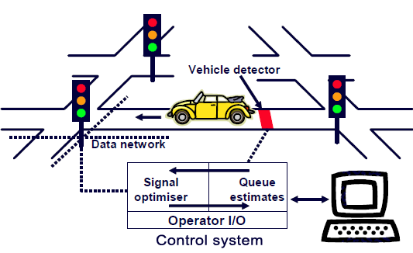

Automatic number plate recognition systems can be used in access control or tracking of stolen vehicles. For example, this technology is used in many companies to grant access only to vehicles of authorized personnel. In some countries, number plate recognition systems installed on country borders automatically detect and monitor border crossings BIET Jhansi

Each vehicle can be registered in a central database and compared to a black list of stolen vehicles In traffic control, vehicles can be directed to different lanes for better congestion control in busy urban communications during the rush hours.

Intelligent Traffic Monitoring System (ITMS) is one such image processing technology used to identify vehicles by their license plates. ITMS is one form of Intelligent Transport Systems (ITS) technology that not only recognizes vehicles but checks each vehicle whether it is a stolen vehicle and is contained in a black list Entire image processing is done in javaScript and react and the list of stolen vehicles is stored in MongoDB Database.

**3.1.2 Purpose of Project**

The main purpose of this project is to detect a license plate from an image provided by a camera. An efficient algorithm is developed to detect a license plate in various luminance conditions. This algorithm extracts the license plate data from an image and provides it as an input to the stage of Car License Plate Recognition. Extracted image of the number plate can be seen on monitor for verification purpose. The scope of this project is to detect the license plate from the given image and observe the output on monitor. This project can work as a base for future improvements in the field of image processing, especially in license plate number recognition.

By adopting the intelligent traffic monitoring system, its installation and construction cost will be reduced substantially. In this paper, the same conventional traffic signal lights would be provided with a “smart-box” to perform real time smart switching ON/OFF (which reduces the cost of installation due to the utilization of same existing traffic lights facility). This smart box is connected to a traffic control center which in turn receives real time data from satellites/telecom towers to track different vehicles through electronic/E number plates (aided with GPS Tracker). This will not only help in tracing the vehicle for traffic management, automatic toll/parking fee deduction and inter-state tourism tax deduction but also will manage to store additional data (complete registration details of the vehicle).

**3.1.3 Objectives**

The work presented here aims at the following

* Study the existing license plate recognition systems.
* Develop a new technique or enhance existing techniques for each phase in a license plate recognition system, Compare the various techniques at hand with the proposed system, and accuracy
* Build a smart fine system and in future enhancement automated fine systems for vehicles.
* Live Traffic detection system and automated traffic light control system.
* Predict the traffic density using machine learning for specific areas by its previous data.
* Automated lost vehicle detection system and information to administration.

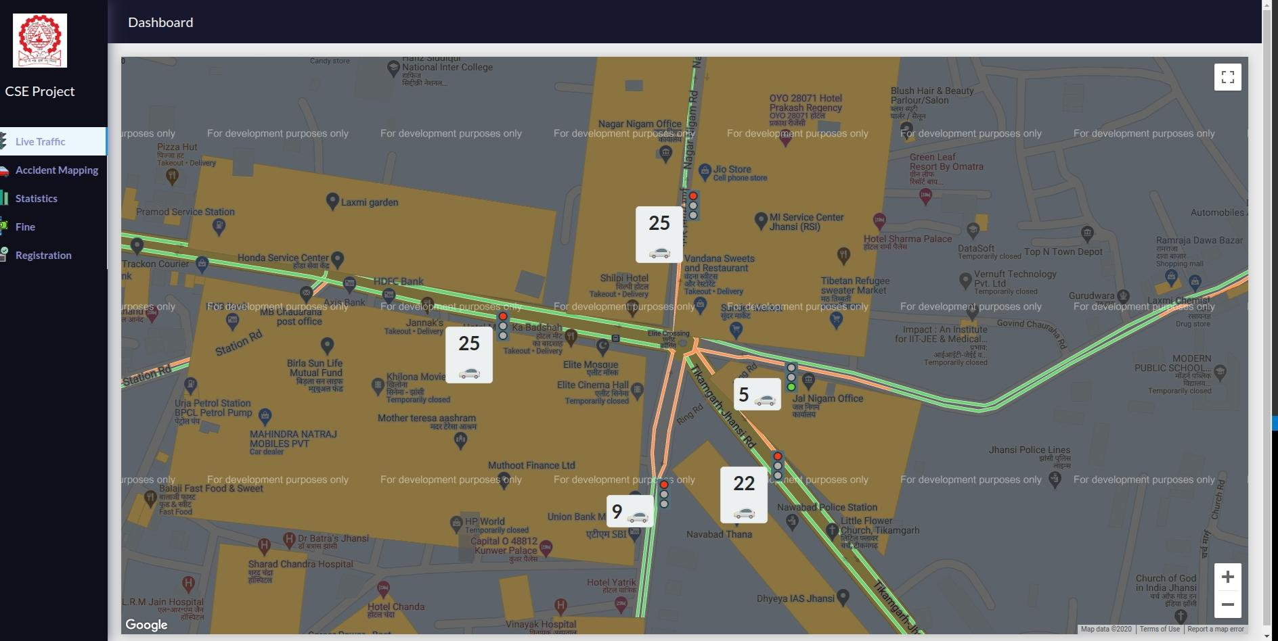

**Traffic light Control by using live traffic data**

**3.1.5 Applications**

Intelligent Traffic Monitoring System is one form of automatic vehicle identification system. This system is of considerable interest, because of their potential applications to areas such as petrol station forecourt surveillance, speed limit enforcement, security, etc Real time ITMS plays a major role in automatic monitoring of traffic rules and maintaining law enforcement on public roads. This area is challenging because it requires an integration of many computer vision problem solvers, which include Object Detection and Character The automatic identification of vehicles by the contents of their license plates is important in private transport applications

**Vehicle Number by its Licence plate**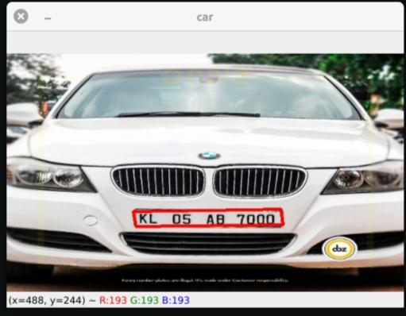

There are many applications of such recognition systems, some of them are below

**Law Enforcement: -** The plate number is used to produce a violation fine on speeding illegal use of bus lanes, and detection of stolen or wanted vehicles License plate recognition technology is popular for security and traffic applications as is based on the fact that all vehicles have license plate and there is no need to install any additional tracking apparatus. The main advantage is that the system can store the image record for future references. The rear part of the vehicle is extracted off the image and is given to the system for processing. The processed result is fed into the database as input. The violators can pay the fine online and can be presented with the image of the car as proof along with the speeding information.

**Parking :-** The Number Plate Recognition module of ITMS system can be used to automatically enter pre-paid members and calculate parking fee for non-members (by comparing the exit and entry The car plate is recognized and stored and upon its exit the car plate read again and the driver is charged for the duration of parking.

**Border Crossing:** - This application assists the registry of entry or exits to a country, and can be used to monitor the border crossings. Each vehicle information is registered into a central database and can be linked to additional information.

**Homeland Security: -** The ITMS systems ability to read strings of alpha-numeric characters and compare them instantaneously to Hot Lists allows a Command Center to organize and strategize efforts in reaction to the information captured, Fixed LPR systems, which can be mounted to bridges, gates and other high traffic areas can help keep a tight watch on entire cities, ports, borders and other vulnerable areas. Every LPR camera is capturing critical data such as color photos, date and time stamps, as well as GPS coordinates on every vehicle that passes or is passed. This incredible database provides a wealth of clues and proof, which can greatly aid Law Enforcement with

* Pattern recognition
* Placing a suspect at a scene
* Watch list development
* Identifying witnesses
* Possible visual clues revealed within the image of a car's immediate environment.

**Automated track the location of stolen vehicle**

a. If any vehicle is a stolen one, and it tries to pass a road crossing, that time an alarm would be generated and a message can be sent to the nearest police station and to the next traffic control room.

1. **LITERATURE SURVEY**

**4.LITERATURE SURVEY**

**4.1 Javascript:**

JavaScript is a programming language that conforms to the ECMAScript.JavaScript is high-level, often just-in-time compiled, and multi-paradigm. It has curly-bracket syntax, dynamic typing, prototype-based object-orientation, and first-class functions.

Alongside HTML and CSS, JavaScript is one of the core technologies of the World Wide Web. JavaScript enables interactive web pages and is an essential part of web applications. The vast majority of websites use it for client-side page behavior,and all major web browsers have a dedicated JavaScript engine to execute it.

**4.1.1 React:**

React is an open-source JavaScript library for building user interfaces or UI components. It is maintained by Facebook and a community of individual developers and companies.React can be used as a base in the development of single-page or mobile applications. However, React is only concerned with rendering data to the DOM, and so creating React applications usually requires the use of additional libraries for state management and routing.

Another notable feature is the use of a virtual Document Object Model, or virtual DOM. React creates an in-memory data-structure cache, computes the resulting differences, and then updates the browser's displayed DOM efficiently.

**4.2 Python**

Python is an interpreted, high-level, general-purpose programming language. Created by Guido van Rossum and first released in 1991, Python's design philosophy emphasizes code readability with its notable use of significant whitespace. Its language constructs and object-oriented approach aim to help programmers write clear, logical code for small and large-scale projects.

Python is dynamically typed and garbage-collected. It supports multiple programming paradigms, including structured (particularly, procedural), object-oriented, and functional programming. Python is often described as a "batteries included" language due to its comprehensive standard library.

Nowadays Python is mostly used for machine learning, data science and artificial intelligence and it has become one of the most popular languages at this time.

**4.2.1 pytesseract**

Python-tesseract is an optical character recognition (OCR) tool for python. That is, it will recognize and “read” the text embedded in images.Python-tesseract is a wrapper for Google’s Tesseract-OCR Engine. It is also useful as a stand-alone invocation script to tesseract, as it can read all image types supported by the Pillow and Leptonica imaging libraries, including jpeg, png, gif, bmp, tiff, and others. Additionally, if used as a script, Python-tesseract will print the recognized text instead of writing it to a file.

**4.3 MongoDb**

MongoDB is a cross-platform document-oriented database program. Classified as a NoSQL database program, MongoDB uses JSON-like documents with optional schemas. MongoDB is developed by MongoDB Inc. and licensed under the Server Side Public License (SSPL).

MongoDB supports field, range query, and regular-expression searches. Queries can return specific fields of documents and also include user-defined JavaScript functions. Queries can also be configured to return a random sample of results of a given size.

**4.4 Introduction of the Project**

License plate recognition systems have received a lot of attention from the research community. Much research has been done on Korean, Chinese, Dutch and English license plates A distinctive feature of research work in this arca is being restricted to specific region, city, or country. This is due to the lack of standardization and different cheese plates (i.s the dimension and the layout of the license plates) This section is an overview of the research carried out so far in this area and the techniques employed in developing an LPR system in lieu of the following four stages image acquisition, license plate extraction license plate segmentation and license plate recognition phases in the next section various existing or novel methods for the image acquisition phase are presented

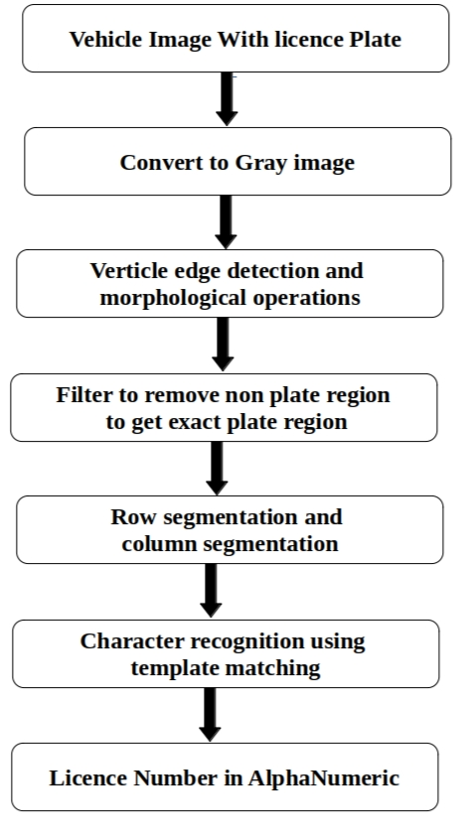

**4.5 Image Acquisition**

Image Acquisition is the first step in an LPR system and there are a number of ways to acquire images, the current literature discusses different image acquisition methods used by various authors. Yan et al. [7] used an image acquisition card that converts video signals to digital images based on some hardware based image pre processing, Naito et al (81 developed a sensing system, which uses two CCDs (Charge Coupled Devices and a prism to split an incident ray into two lights with different intensities.



**4.6 License Plate Extraction**

License plate extraction is the most important phase in an LPR vysten This discusses some of the previous work done during the extraction phase Hontanit proposed a method for extracting characters without prior knowledge of their position and size of the image. The technique is based on scale shape analysis, which in turn is back the assumption that characters have line type shapes locally and blodtype shapes globally In the scale shape analysis, Gaussian fishers at various scales blur the given image.

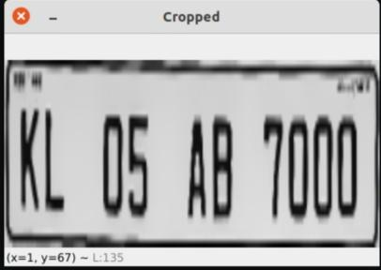

**4.7 Segmentation**

This section presents the methods that were used to classify and then recognize the individual characters The classification is based on the extracted features. These features are then classified using either the statistical, syntactic or neural approaches Some of the previous work in the classification and recognition of characters is as follows, Hasen discusses a statistical pattern recognition approach for recognition but their technique found to be inefficient. This approach is based on the probabilistic model and uses statistical pattern recognition approach. Cowell discussed the recognition of individual Arabic and Latin characters.

**4.8 Character Recognition**

Optical character recognition (OCR) has been a topic of interest since possibly the late 1940's when Jacob Rabinow started his work in the field. The earliest PCR machines were primitive mechanical devices with fairly high failure rates. As the amount of new written material increased, so did the need to process it all in a fast and reliable manner, and these machines were clearly not up to the task. They quickly gave way to computer-based OCR devices that could outperform them both in terms of speed and reliability

Today there are many OCR devices in use based on a plethora of different algorithms. All of the popular algorithms sport high accuracy and most high speed, but still many suffer from a fairly simple flaw when they do make mistakes and they all do), the mistakes are often very unnatural to the human point of view. That is, making a "5" for an "S'' is not too surprising because most people are willing to agree that these two characters are similar, but mistaking a "5" for an "M" is counter intuitive and unexpected Algorithms make such mistakes because they generally operate on a different set of features in humans for computational reasons. Humans observe strokes and the relations between them while algorithms measure anything from Transformation Ring Projections of a character to the Fourier Transform of the Horizontal Vertical Projections of a character. These methods do work and are often computationally efficient, but they make the computer sce letters through a decidedly non-human set of eyes

The importance of making the same sorts of mistakes as a human may not be immediately obvious, but it is important to realize that the main purpose of OCR is to facilitate communication between humans Mistakes typical of humans can be more readily corrected by humans (ic "Save is easier to connect with "Save" the "Mave").

This paper describes an algorithm that attempts to work with a subset of the features in a character that a human would typically score for the identification of machine-printed English characters Its recognition rate is currently not as high as the recognition rates of the older, more developed character recognition algorithms, but it is expected that if it were expanded to work with a larger set of features this problem would be removed If it were expanded to use more features, it would be made correspondingly slower with the advent of faster microprocessors this fact is not viewed as a crippling problem

The characters in most Western character sets can comfortably be described using only an eight by eight grid Since the focus of this algorithm is currently just machine printed English characters the algorithm was designed to handle eight by eight data. It should not be impossible to use this algorithm on characters with higher resolution, but some method of data reduction would have to be applied to the raw data first A block reduction method should produce acceptable results for most machine printed data, but there is no reason that a good thinning algorithm could not do just as well provided that the input needs of this algorithm are properly understood

The algorithm presently avoids thinning and other preprocessing, by assuming that the input eight by eight data is not particularly aberrant -- lines in an eight by eight grid should not normally be thicker than two pixels. With this assumption at the proceeds to look for feature points

A feature point is a point of human interest in an image, a place where something happens. It could be an intersection between two lines, or it could be a corner, or it could be just a dot surrounded by space. Such points serve to help define the relationship between different strokes. Two strokes could fully cross each other, come together in a "Y" or a T intersection, form a comer or avoid each other altogether. People tend to be sensitive to these relationships; the fact that the Lines in a "Z" connect in a certain way is more important than the individual lengths of those lines. These relationships are what should be used for character identification, and the feature points can be exploited for the task

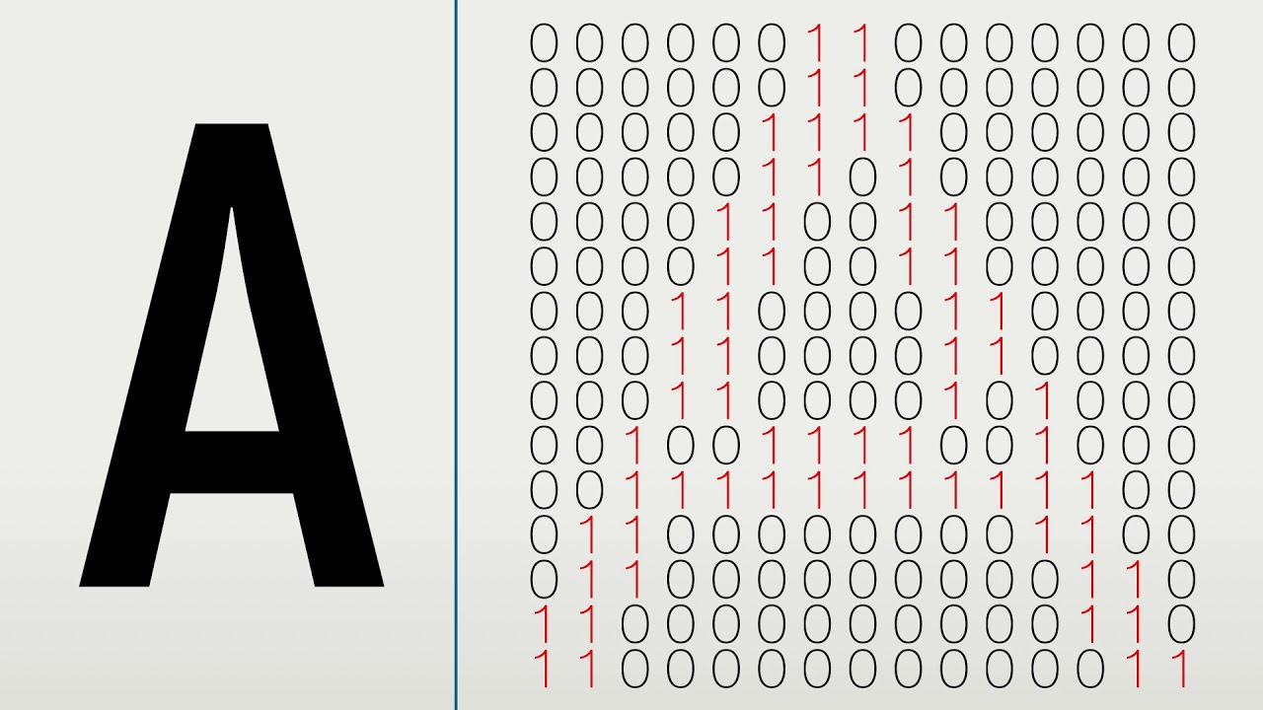

**5 HARDWARE AND SOFTWARE REQUIREMENTS**

**5 HARDWARE AND SOFTWARE REQUIREMENTS**

**5.1 Software Specification**

|  |  |
| --- | --- |
| Operating system | Windows 10/Linux/Mac |
| Programming language | Javascript,Python |
| IDE | Visual code studio |

**5.2 Hardware Specification**

|  |  |
| --- | --- |
| Processor | Intel pentium |
| Monitor | LED,VGA panel |
| Ram | 512MB |

**6 SYSTEM ANALYSIS**

**6 SYSTEM ANALYSIS**

**6.1 Problem Definition**

Traffic problems are significant in developing or developed countries. Massive integration of information technologies into all aspects of life caused demand for processing vehicles as conceptual in information systems. Because a standalone system without any data also needs to transform information about vehicles between the reality and information systems. This achieved human agent, or by special intelligent equipment which is able to recognize vehicles by their number plates in real environment and reflect it into conceptual resources. Because of this, various recognition techniques have been developed number plate recognition systems are today used in various traffic and security applications, such as parking, access and border control, tracking of stolen .Till now, all LPR systems have been developed using neural networks and Python and none have the capability to access a database to efficiently execute vehicle. This work proposes to implement the system using Javascript and Mongodb to make the system faster and more efficient.

**6.2 Proposed Solution**

For real time application, the system has a video camera (frame grabber) which acquires the vehicles from rear or front.The images of various parked vehicles have been acquired manually, thereafter fed to the software where they are first converted into grayscale images. Brightness, contrast and gamma adjustments are made to optimum values to enhance the number plate and its digits. Then the highest probability of the number plate is masked and Then the resulting region interest is scanned for characters and numerals by continuously changing the coordinates of the bounding box in an OCR session. The output of OCR is saved in a text file and displayed in the list box of the The software displays the number and terminates the execution of the program so that the next image can be processed. Meanwhile, after the software displays the number in the message box, a connection to the JavaScript connector MongoDb made a query database about the existence of the detected number plate in the stolen vehicles table.

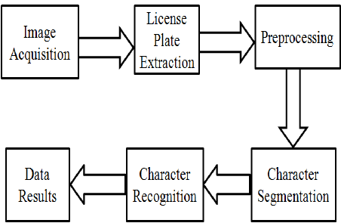

**6.3 Structure of the Proposed System**

The system presented is designed to recognize license plates from the front and rear of the vehicle. Input to the system is an image acquired by taking the snapshot of the running video acquired by a digital camera that consists of a license plate and its output is the recognition of characters on the license plate The system consists of the standard four main modules in an ITSM system, viz Image acquisition and License plate extraction License plate segmentation License plate recognition and matching the plate number with the database. The first task acquires the image and extracts the region that contains the license plate The second task isolates the characters, letters and numerals (total of 10 digits), as in the case of Indian License Plates The third task identifix or recognizes the segmented characters The last task executes a query to the database to find the vehicle to be a stolen vehicle or not.

**6.3.1 Image Acquisition**

This is the first phase in an ITMS system. This phase deals with acquiring an image by an acquisition method. In our proposed system we used a high resolution digital camera to acquire the input image. The input image is 1200 x 1600 pixels.

**6.3.2 License Plate Extraction**

License Plate Extraction is a key step in an ITMS system, which influences the accuracy of the system significantly. This phase extracts the region of interest, i.e., the license plate, from the acquired image. The proposed approach involves "Masking of a region with high probability of license plate and then scanning the whole masked region for license plate".

**6.3.3 License Plate Segmentation**

License Plate Segmentation, which is sometimes referred to as Character Isolation takes the region of interest and attempts to divide it into individual characters. In the proposed system segmentation is done in the OCR section.

**6.3.4 License Plate Recognition**

The second phase in the ITMS system is to recognize the isolated characters. After splitting the extracted license plate into individual character images, the character in each image can be identified. There are many methods used to recognize isolated characters. In the proposed system we are using Optical Character Recognition with template matching.

**6.3.5 License Plate Matching**

The last phase of ITMS system is to check if the recognized licence plate exists in the list of black listed vehicles or stolen vehicles. If found to exist in the database, a message is sent to the next traffic booth where the vehicle is heading towards or a signal is sent to the appropriate unit for allowing or rejecting the entry to a particular secured area.

**6.4 Feasibility Study**

It is the high level capsule version of the entire requirement analysis process. The objective of feasibility study is to determine whether the proposed system can be developed with available resources. There are three steps to be followed for determining feasibility study of proposed systems.

1. Technical feasibility

2. Operational feasibility

3. Economical feasibility

**6.4.1 Technical Feasibility**

It is concerned with hardware and software feasibility. In this study, one has to test whether the proposed system can be developed using existing technology or not. As per requirements, the system to be developed should have speed response because of fast exchange of information, reliability, security, scalability, integration and availability To meet these requirements, we have found Java as a next choice because of its features rich library of image processing functions, mathematical operations, and reusability.

**6.4.2 Operational Feasibility**

Operational feasibility determines whether the proposed system satisfied the user objectives and can be fitted in to current system operation The system "Intelligent Traffic Monitoring System" can be justified as operationally feasible based on the following:

* The methods of processing and presentation are completely acceptable by the users because they meet all their requirements
* The users have been involved during the preparation of requirement analysis and design process.
* The system will certainly satisfy the user objectives and it will also enhance their capability and effectiveness.

**6.4.3 Economical Feasibility**

This includes an evaluation of all incremental costs and benefits expected if the proposed system is implemented. Costs-benefit analysis which is to be done during economic feasibility delineates costs for project development and weighs them against So developing this system is economically feasible.

**7 SYSTEM DESIGN**

**7.SYSTEM DESIGN**

The purpose of the design phase is to plan a solution of the problem specified by the requirement document. This phase is the first step in moving from the problem domain to the solution domain. In other words, starting with what is needed, design takes us towards how to satisfy the needs. The design of the system is the most critical factor affecting the quality of the software and has a major impact on testing and maintenance. The output of this phase is the design document.

The design document is often divided into two separate phase

* System design
* Detailed design

**7.1 System Design**

Software design sits at the technical kernel of the software engineering process and is applied regardless of the development paradigm and area of application Design is the first step in the development phase for any engineered product or system. The designer's goal is to produce a model or representation of an entity that will later be built. Beginning, once system requirements have been specified and analysed system design is the first of the three technical activities -design, code and test that is required to build and verify software The importance can be stated with a single word "Quality Design is the place where quality is fostered in software development. Design provides us with representations of software that can assess for quality Design is the only way that we can accurately translate a customer's view into a finished software product or system Software design serves as a foundation for all the software engineering steps that follow Without a string design we risk building an unstable system - one that will be difficult to test, one whose quality cannot be assessed until the last page.

During design, progressive refinement of data structure, program structure and procedural details are developed, reviewed and documented System design can be viewed from wither technical or project management perspective From the technical point of view design is comprised of four activities - architectural design, data structure design, interface design and procedural design There is basically two type of system design that are available.

**Logical design**

The logical design of a system pertains to an abstract representation of the data flows, inputs and outputs of the system. This is often conducted via modelling, using an over-abstract (and sometimes graphical) model of the actual system. In the context of systems design are included. Logical design includes ER Diagrams e Entity Relationship Diagram.

**Physical design**

The physical design relates to the actual input and output processes of the system This is laid down in terms of how data is input into a system, how it is verified authenticated, how it is processed, and how it is displayed as output In Physical

design, following requirements about the system are decided

1. Input requirement.

2. Output requirements,

3. Storage requirements,

4. Processing Requirements,

5. System control and backup or recovery

**7.2 Detailed Design**

During detailed design the internal logic of each of the modules specified in the system design is decided

In system design the focus is on identifying the modules, whereas during detailed design the focus is on designing the logic for each of the modules. In other words, in system design the attention is on what components are needed, while in detailed design how the components can be implemented in the software During phase further details of the data structures and algorithmic design of each of the module is usually specified in a high level design description language, which is independent of the target language in which he software will eventually be implemented.

Thus, a design methodology is a systematic approach to creating a design application of a set of techniques and guidelines.

**7.3 Process Model (ERD):**

ERD uses three measure obstructions to describe the data

**Development & Design of a New Logistics Information Management System**

* Entities which are distinct in the organization, ie it is conceptual representation of an object
* Relationship which have meaningful interaction between the object
* Attributes which have properties of entities and relationships.
* Three types of relationships exist among entities are following - A one to one relationship is associated between two entities
* A one to many one relationship describe an entity that may have two or more entities related to it.
* A many to many relationship describe the entities that may have many relationship in both direction

**7.4 Data Flow Diagram**

Data flow diagrams are the basic building blocks that define the flow of data in a system to the particular destination and difference in the flow when any transformation happens. It makes the whole procedure like a good document and makes it simple and easy to understand for both programmers and non-programmers by dividing into the sub process.

The data flow diagrams are the simple blocks that reveal the relationship between various components of the system and provide high level boundaries of a particular system as well as provide detailed overview system elements.

The data flow diagrams start from source and end the destination level decomposes from high level lower levels. The important things to remember about data flow diagrams indicate the data flow for way but not for loop structures and don't indicate the time factors.

This section reveals about the data flow analysis which states about data that have been used, classification of data flow diagrams based their functions and the other different levels used the

**Data flow processes:**

it will define the direction the data flow from one entity another

**Process:**

Process defines the source from where the output generated for the specified input states the actions performed on data such that they are transformed, stored distributed

**Data store:**

It is the place where the data is stored after extraction from the data source.

**Source:**

It the starting point destination point the data, starting point from where the

external entity acts cause flow the data towards destination

**Level 0 Data Flow Diagram**

DFD level is the highest level view of the system. contains only one process which represents the whole function of the system. doesn't contain any data stores and the data stored with int the process.



**Level 1 Data Flow Diagram**



**Level 2 Data Flow Diagram**

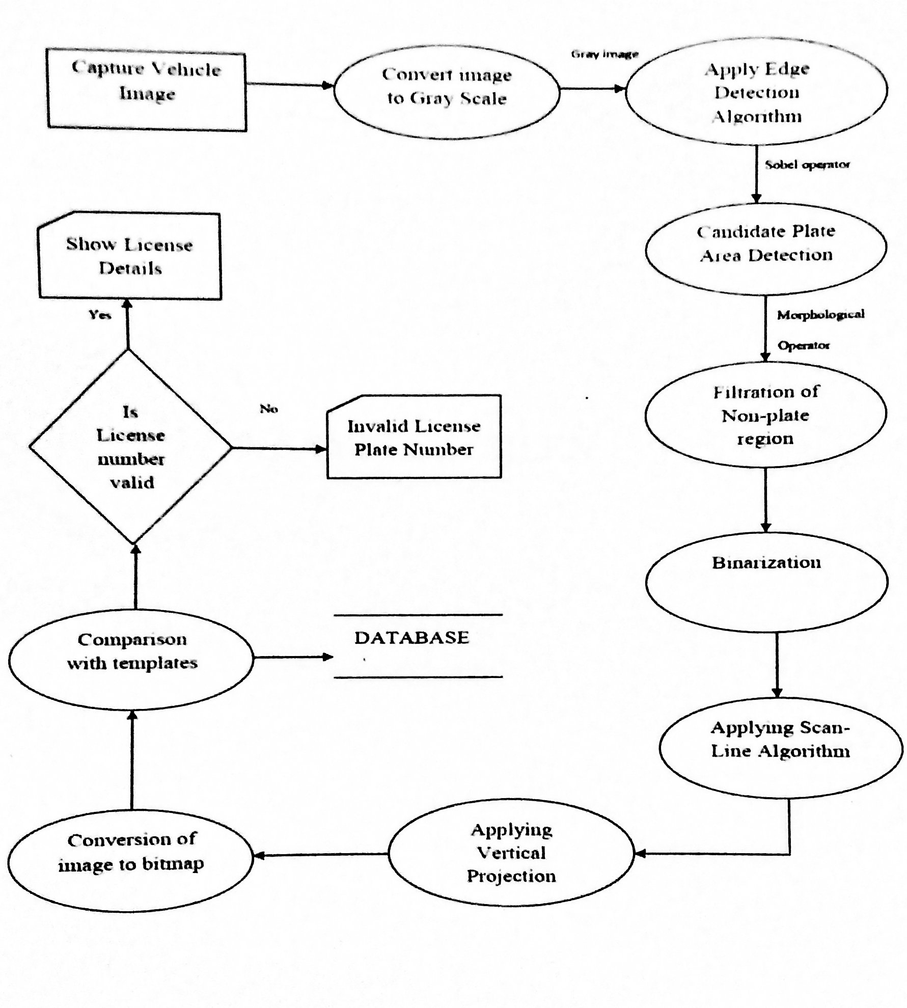

**8 SAMPLE SCREEN**

**HOME SCREEN**

**ELITE CROSSING JHANSI,** 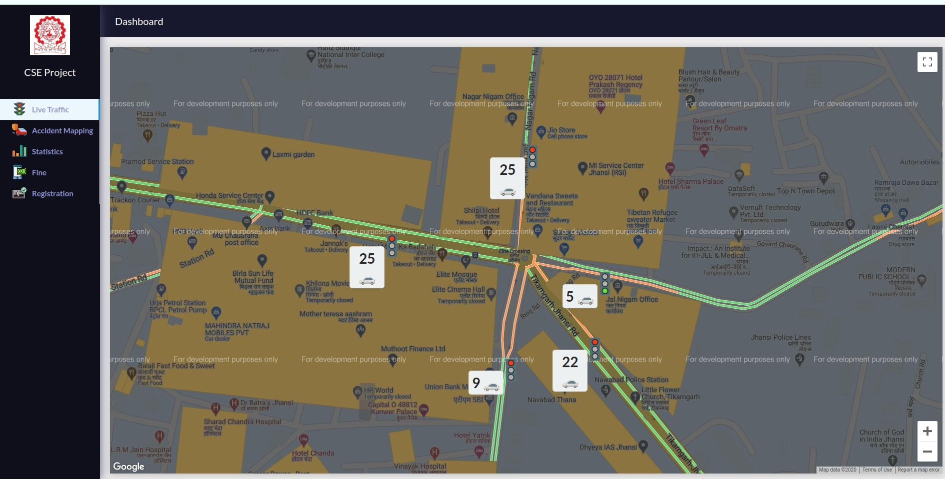

**TRAFFIC LIGHT CONTROL**

**HOME SCREEN 2**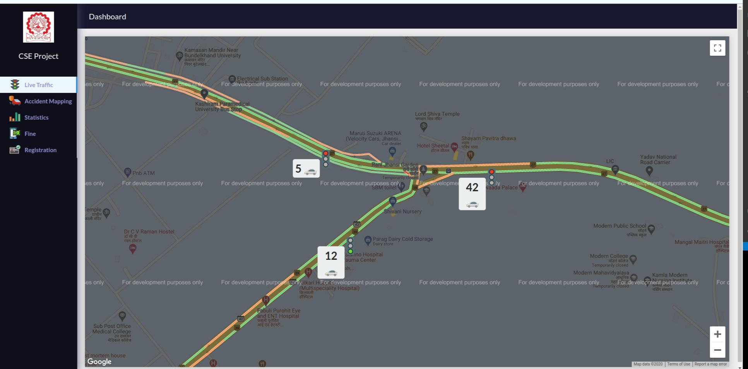

**TRAFFIC LIGHT CONTROL AT JHANSI, KANPUR HIGHWAY JUNCTION.**

**TRAFFIC DENSITY**

**TRAFFIC DENSITY OF KANPUR, JHANSI HIGHWAYS**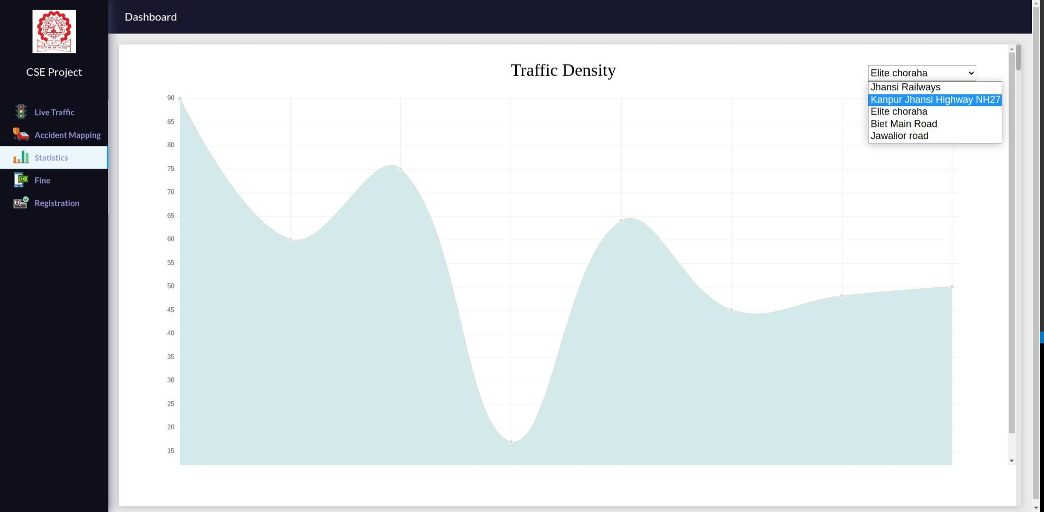

**VEHICLE REGISTRATION**

**REGISTRATION FORM** 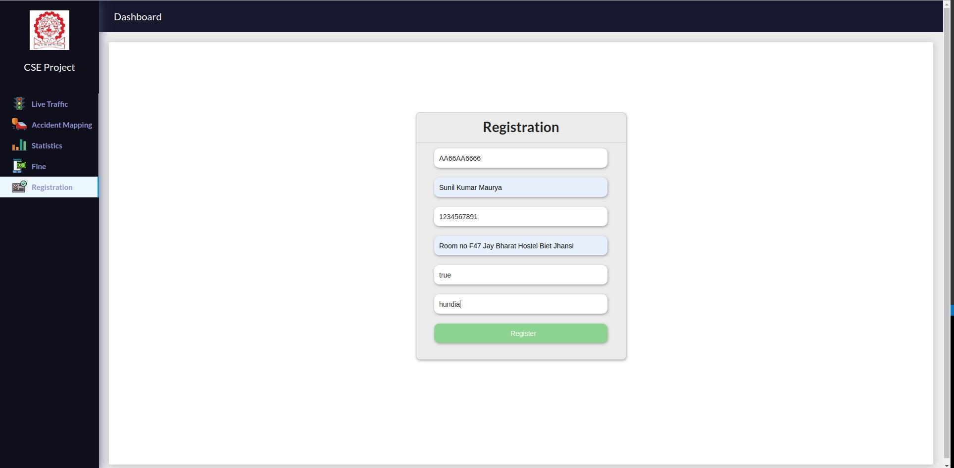

**FOR VEHICLE REGISTRATION AND**

**ALSO FOR MISSING COMPLAIN**

**VEHICLE DETAIL BY LICENSE NUMBER**

**VEHICLE DETAIL BY ITS LICENSE NUMBER**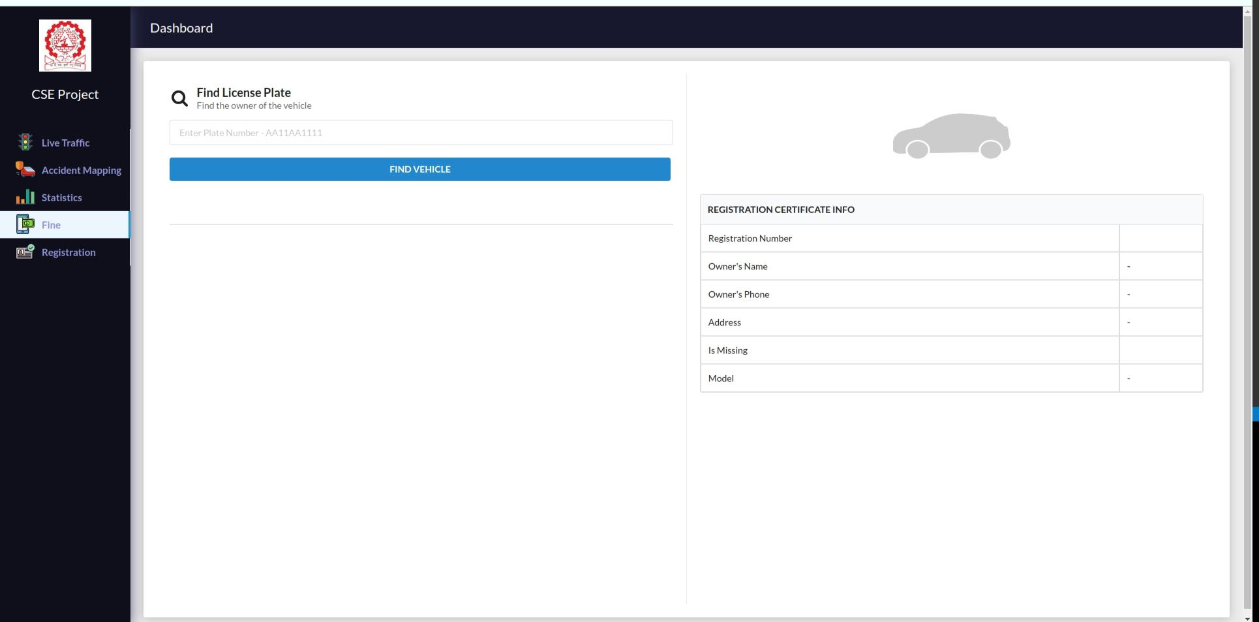

**SMART FINE SYSTEM**

**SEND 500 FINE TO VEHICLE OWNER**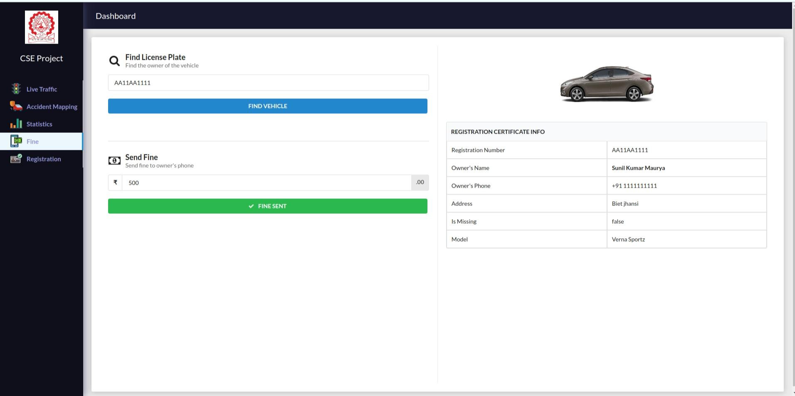

**LICENSE NUMBER BY USING VEHICLE LICENSE PLATE**



**VEHICLE PLATE DETECTION**

**BIFILTER IMAGE OF VEHICLE**

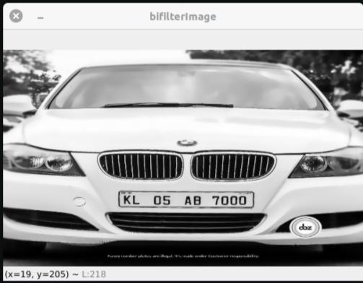

**CONVERT THE IMAGE IN BLACK AND WHITE**

**THRESHOLD IMAGE OF VEHICLE FOR OCR DETECTION**

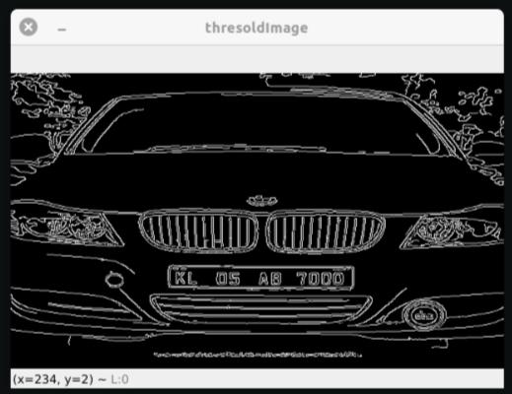

**THIS IS THRESHOLD IMAGE MEANS BLACK IS MORE BLACK AND WHITE IS MORE WHITE, SO THIS HELP IN CHARACTER RECOGNITION.**

**FINAL VEHICLE NUMBER PLATE**



**VEHICLE LICENSE NUMBER IS**

**KL05AB7000**

**9 SOFTWARE TESTING STRATEGIES**

**9 SOFTWARE TESTING STRATEGIES**

One of the main requirements of the software development is to develop bug free reliable system During the process of development of any application there is always a possibility of some errors being developed. And also the software may not be as user asked for. Thus.it becomes imperative that the software should be checked at every step. This helps in a bug free reliable system. If there is any bug or alteration that have to be made that can be done at the preliminary level as the application gets more complicated after every step.

The objective of the testing is to discover bugs of the application. To fulfill the objective a series of test steps such as Unit Testing. Validation Testing System Testing where planned and executed testing objective includes

* Testing is a process of executing a program with the intent of finding an error.
* A good test case is one that has a high probability of finding an undiscovered error.
* A successful test is one that uncovers an undiscovered error.

**9.1 Various Testing Approaches**

**BLACK BOX TESTING:-**Black Box Testing relates to tests that are performed as the

software interface. Although they are designed to identify errors, black box tests are used to demonstrate that software functions are operational that inputs are correctly accepted and

the output is correctly produced

**WHITE BOX TESTING:-**White box testing is a test case design approach that employs the control architecture of the procedural design to produce test cases. Test case can be divided such that they

* Guarantee that all independent paths within a module have been exercised at least once.
* Exercise all logical decisions on their true and false side.
* Execute all loops at their boundaries and within their operational bonds.
* Exercise internal data structure to insure their validity.

**UNIT TESTING:-**This test focuses verification effort on the small unit or design

module. Here using a test plan prepared in design description as guide, important control paths are are tested to uncover errors within boundary of the module.

Boundary condition are tested to ensure module operate properly at boundaries established to limit or restrict processing. All paths in the control structure are exercised to ensure all statements in a module are executed at least once and finally all errors handling paths are tested to see message are intelligent Corresponds to errors encountered and provide enough description for the cause of errors.

I**NTEGRATION TESTING:-**The focus of the test here is on the design and

construction of software architecture. This is a systematic technique for construction of the program structure and conducting tests to uncover errors associated with interfacing. The objective here is to take unit tested module and build a program that is dictated by signs. All fractions integrated successfully after successful completion of development and unit testing.

**VALIDATION TESTING:-**All the culmination of integration testing software completed assembled as a package, interfacing errors have been uncovered and corrected and a final series of software testing, validation test begins.

**9.2 Test Plan**

**9.2.1 Introduction**

Testing defines the status of the working functionalities of any particular system. Through testing particular software one can't identify the defects in it but can analyse the performance of software and its working behaviour By testing the software we can find the limitations that become the conditions on which the performance is measured on that particular level. In order to start the testing process the primary thing is requirements of the software development cycle. Using this phase the testing phase will be easier for testers .The capacity of the software can be calculated by executing the code and inspecting the code in different conditions such as testing the software by subjecting it to different sources as input and examining the results with respect to the inputs After the designing phase, the next phase is to develop and execute the code in different conditions for any errors and progress to the developing phase Without testing and execution, the software cannot be moved to the developing phase There are two types of testing The functional testing, which defines the specified function of a particular code in the program. This type of testing gives us a brief description about the program's performance and security in the various functional areas.

The other type of testing is non-functional testing. Non-functional testing defines the capabilities of particular software like its log data etc. It is opposite to functional testing and so will not describe the specifications like security and performance.

The performance of the particular program not only depends on errors in coding The errors in the code can be noticed during execution, but the other types of errors can affect the program performance like when the program is developed based on one platform that may not perform well and give errors when executed in different platforms. compatibility is another issue that reduces the software performance. The code tuning helps us in optimising the program to perform at its best utilizing minimal resources possible under varied conditions

**9.2.2 Aim of Testing**

The main aim of testing is to analyse the performance and to evaluate the errors that occur when the program is executed with different input sources and running in different operating environments.

In this project, we developed a steganographic application based on Microsoft Visual Studio which focuses on data hiding based on vanous algorithms. The main aim of testing in this project is to find the compatibility issues as well as the working performance when different sources are given as the inputs.

**9.3 Test Cases**

Tests have been performed throughout the implementation of the application: When the tests have found an error, the problem was found and resolved. The following tests cases were done after the system was "completed

The main aim of test cases is to analyse the performance and to evaluate the errors that occur when the program is executed with different input sources and running in different operating environments.

**9.3.1 Start Up Screen Display**

|  |  |  |  |
| --- | --- | --- | --- |
| **TEST** | **DESCRIPTION** | **EXPECTED OUTCOME** | **AS EXPECTED** |
| 1 | Open The software | The software will be loaded up as intended. There are no glitches or anomalies. | Yes |
| 2 | Enter User Name  &  Password | The required interface will appear. | Yes |
| 3 | Action > Enter Wrong User Name | The next window will not appear and it will give a error | Yes |
| 4 | Action > Enter Wrong User PASSWORD | The next window will not appear and it will give a error | Yes |

**9.3.2 For entering the record of Stolen Vehicles**

|  |  |  |  |
| --- | --- | --- | --- |
| **TEST** | **DESCRIPTION** | **EXPECTED OUTCOME** | **AS EXPECTED** |
| 1 | Click on the Record Button | Form will be shown | Yes |
| 2 | Enter the information in the field | The information will be entered | Yes |
| 3 | Click on Submit Button | The record will be saved in the database | Yes |
| 4 | Leave the marked fields empty | If the marked fields are left empty, the alert box will prompt up and will say to fill the fields is mandatory | Yes |

**9.3.3 For Detecting the Number Plate**

|  |  |  |  |
| --- | --- | --- | --- |
| **TEST** | **DESCRIPTION** | **EXPECTED OUTCOME** | **AS EXPECTED** |
| 1 | Click on Detect Number Plate | The required interface will be displayed | Yes |
| 2 | Image Load Snapshots | The "Load Snapshots form Directory" Dialog Box is displayed | Yes |
| 3 | Click on open Button | The image will be loaded | Yes |
| 4 | Click on recognize plate | The number on the license plate will be displayed | Yes |

**10 CONCLUSION**

**10. CONCLUSION**

The process of vehicle number plate recognition requires a very high degree of accuracy when we are working on a very busy road or parking which may not be possible manually as a human being tends to get fatigued due to monotonous nature of the job and they cannot keep track of the vehicles when there are multiple vehicles are passing in a very short time.To overcome this problem, many efforts have been made by the researchers across the globe for last many years.

A similar effort has been made in this work to develop an accurate and automatic number plate recognition system, Automatic traffic light control using google Api live traffic density data, smart fine system and also We can track the lost vehicle using vehicle number plate detection. We have used Python for machine learning and optical character recognition with mongodb database to obtain the desired results. The setup has been tested for 30 vehicles containing different number plates from different states. In the process of final evaluation after optimizing the parameters like brightness, contrast and gamma, adjustments, optimum values for lightening and the angle from which the image is to be taken. We get an overall efficiency of 98% for this system Though this accuracy is not acceptable in general, still the system can be used for vehicle identification. It may be concluded that the project has been by and far successful. It can give us a relative advantage of data acquisition and online warning in case of stolen vehicles which is not possible by traditional manhandled check posts While thousands of vehicles pass in a day.

**11 FUTURE ENHANCEMENT**

**11 FUTURE ENHANCEMENT**

* Build up a new image acquisition system with better focus and illumination
* Use our real time data at place of google api traffic data and Implement the camera at traffic lights using IOT and get better real time data.
* Implement better traffic light control using our real time data from camera.
* Enhance the stolen vehicle by using gps and image processing technology.
* Predict more better traffic density of the area using 2 years previous data and create a better prediction model.

**13 REFERENCES**

**13 REFERENCES**

[1]. **Fulu Li ; Barabas, J. ; Mohan, A. ; Raskar**, “Information

processing for image sensing under unfavorable photographic

conditions “, R. Information Sciences and Systems (CISS),

2013 47th Annual Conference on

DOI:10.1109/CISS.2013.6624258 Publication Year: 2013 ,

[2]. http://vip.uwaterloo.ca/publications/vehicle-trackingocclusion-and-clutter ece-eee.final-year-projects.in/a/429-

rfid-based-toll-deduction-system.html

[3]. **Jing Xu ; Tao Lu** ; Lingling Gao, “Design and Application of

In-Vehicle Terminal for Car Network System Based on

ARM9”,

Education Technology and Training, 2008. and 2008

International Workshop on Geoscience and Remote Sensing.

ETT and GRS 2008. Publication Year: 2008, Page(s): 324 -

327

[4]. **en.wikipedia.org/wiki/GPS_tracking_unit**

[5]. researchnews.osu.edu/archive/smartbox.htm

[6]. **Arun Sasi, Lakshmi R Nair,** M.Tech Student, Electrical and

Electronics Department, Amrita School of Engineering, Tamil

Nadu, India, “Vehicle anti-theft system based on an

embedded” IJRET: International Journal of Research in

Engineering and Technology eISSN: 2319-1163 | pISSN:

2321-7308, pages: 581-585

[7]. **en.wikipedia.org/wiki/E-challan**

[8]. www.valeo.com/en/our/comfort-and-driving-assistancesystems

[9]. http://www.e-plate.com/

[10]**. A. Sankara Narayanan, QR Codes and Security Solutions,**

Department of Information Technology, Salalah College of

Technology, Sultanate of Oman, International Journal of

Computer Science and Telecommunications [Volume 3, Issue

7, July 2012], pages 69-72

[11]. www.cisco.com/web/IN/about/network/smart_traffic.html